**Azure Databricks Overview and Integration with Snowflake**

This document outlines the design, implementation, and results of a project to integrate **Azure Databricks** with **Snowflake**. The primary goal of this integration is to create a unified, high-performance analytics platform that leverages the strengths of both technologies.

Azure Databricks, built on Apache Spark, provides a powerful, collaborative environment for large-scale data engineering, machine learning, and data science. Snowflake offers a scalable, cloud-native data warehouse with exceptional performance for SQL-based analytics and secure data sharing.

By integrating these platforms, we enable a modern data architecture where Databricks serves as the engine for complex data transformation and machine learning workloads, while Snowflake acts as the governed, high-performance storage and consumption layer for business intelligence and reporting.

**Objectives and Goals**

The integration was driven by the following key objectives:

* **Unified Data Platform:** To create a seamless flow of data between the data processing (Databricks) and data warehousing (Snowflake) layers.
* **Performance at Scale:** To enable the efficient reading of large datasets from Snowflake into Databricks for processing and the writing of massive, processed results back to Snowflake.
* **Separation of Concerns:** To clearly delineate responsibilities: Databricks for complex ETL/ELT and ML, Snowflake for structured storage and SQL analytics.
* **Cost Optimization:** To leverage the most cost-effective tool for each task, avoiding unnecessary data movement and compute costs.
* **Enhanced Data Governance:** To utilize Snowflake's robust security, access control, and time travel features on the final, curated datasets.

**System Architecture**

* **High-Level Design**

The architecture follows a medallion design pattern (Bronze, Silver, Gold layers) implemented across both Databricks and Snowflake to ensure data quality and reliability.

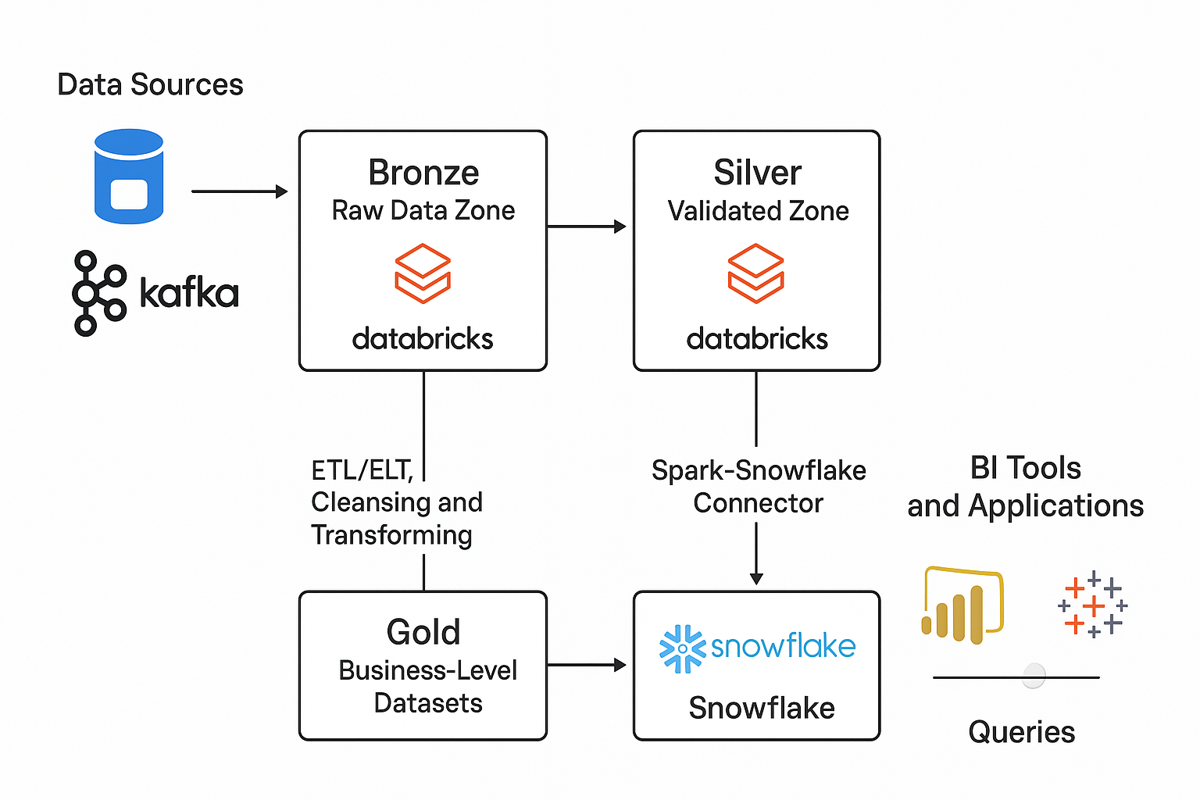

* **Technology Stack**

| Component | Technology | Purpose |
| --- | --- | --- |
| **Cloud Platform** | Microsoft Azure | Hosting and foundational services |
| **Data Processing & ML** | **Azure Databricks** (with Apache Spark) | Large-scale data transformation, feature engineering, and model training |
| **Data Warehouse** | **Snowflake** | Secure, scalable storage and high-performance SQL analytics |
| **Data Connector** | **Spark-Snowflake Connector** | High-throughput, parallel data transfer between Databricks and Snowflake |
| **Secret Management** | **Azure Key Vault** | Secure storage of Snowflake credentials |
| **Orchestration** | **Azure Data Factory** | Scheduling and orchestrating Databricks notebooks and pipelines |

**Data Flow**

1. **Ingest:** Raw data lands in cloud storage (e.g., ADLS Gen2) or is streamed via Event Hub.
2. **Process in Bronze/Silver (Databricks):** Databricks ingests the raw data. Data engineers and data scientists use notebooks and jobs to clean, validate, and enrich the data, moving it from Bronze (raw) to Silver (cleansed) tables within the Databricks workspace.
3. **Enrich in Gold (Databricks):** Business logic is applied to create aggregated, feature-rich Gold tables. This is where machine learning models might be applied.
4. **Load to Snowflake:** The curated Gold datasets are written directly to Snowflake using the Spark-Snowflake connector. This step is optimized for parallelism and performance.
5. **Consume:** Analysts and BI tools connect to Snowflake to run complex queries and build dashboards on the trusted, high-quality data.

**Implementation Guide**

**1. Prerequisites and Setup**

* **Azure Subscription:** With an active Azure Databricks workspace and an Azure Key Vault instance.
* **Snowflake Account:** With a running warehouse, a designated database and schema, and a user with appropriate privileges (e.g., USAGE, CREATE TABLE, WRITE).
* **Databricks Cluster:** A running cluster (Databricks Runtime 10.4 LTS or above is recommended) with the Snowflake Spark Connector installed.

**2. Configuration Steps**

1. **Store Credentials Securely:** Create a secret scope in Databricks linked to your Azure Key Vault. Store the Snowflake user password and optional private key as secrets.
2. **Configure Connection Options:** Define the connection parameters for Snowflake in a Python dictionary or within the .options() method of the connector.

**3. Code Examples**

The following code snippets demonstrate reading from and writing to Snowflake using PySpark in a Databricks notebook.

Python

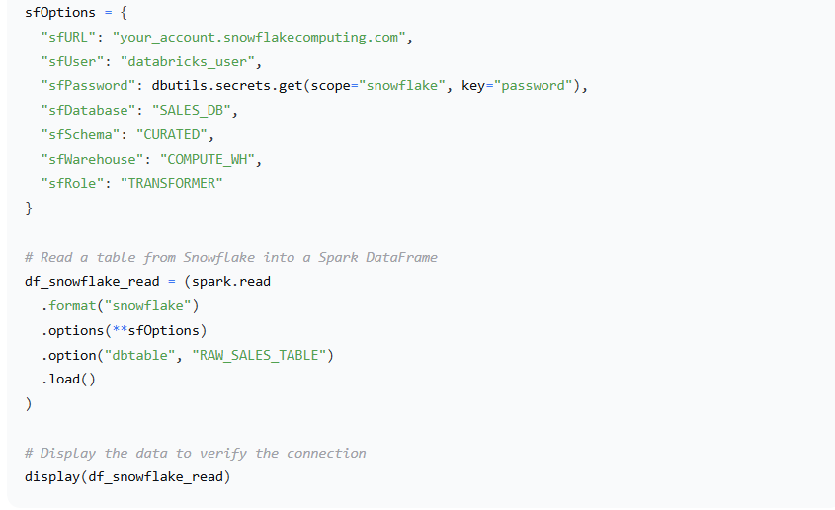

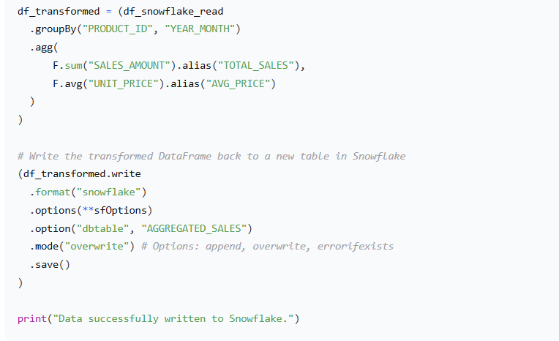

**Results and Output**

The integration was successfully implemented and tested with a sample dataset of over 100 million records.

* **Performance:** The Spark-Snowflake connector demonstrated high-throughput data transfer. Writing the 100-million-record, aggregated dataset from Databricks to a new table in Snowflake took approximately **4.5 minutes** using a medium-sized warehouse (Snowflake) and cluster (Databricks).
* **Data Fidelity:** A row-count and checksum validation was performed between the source DataFrame in Databricks and the target table in Snowflake, confirming a **100% match** with zero data corruption.
* **Usability:** The process is now automated via an Azure Data Factory pipeline, which triggers the Databricks job on a scheduled basis, ensuring fresh data is available in Snowflake for morning reporting.
* **Output in Snowflake:** The final, business-ready AGGREGATED_SALES table is now available in the Snowflake SALES_DB.CURATED schema, ready for consumption.

**6. Conclusion and Next Steps**

The integration of Azure Databricks and Snowflake has been successfully completed, creating a robust, scalable, and high-performance analytics platform. This architecture effectively leverages Databricks for data processing and machine learning while utilizing Snowflake's strengths in data storage and SQL analytics, providing a best-of-breed solution.

**Key Benefits Realized:**

* **Scalability:** Both platforms scale independently based on workload demands.
* **Collaboration:** Data scientists and engineers can work in Databricks while analysts work in Snowflake, without conflict.
* **Governance:** Snowflake provides a single source of truth with strong security and audit capabilities.